Title ………………………………….

Firstname Lastname*, Firstname Lastname**, Firstname Lastname***

*Key words*: keyword1, keyword2, keyword3 (List three to six pertinent keywords specific to the article; yet reasonably common within the subject discipline)

Abstract

The abstract should summarize the context, content and conclusions of the paper in about 2,500 characters (including spaces). It should not contain any reference citations or displayed equations. Typeset the abstract in 9.5 pt Optima Italic with single inter line.

# General Appearance

Contributions will be reproduced by using the author's submitted typeset manuscript. It is therefore essential that the manuscript be in its final form, and of good appearance because it will be printed directly without any editing. The manuscript should also be clean and unfolded.

# The Main Text

Contributions are to be in Italian and in English. Authors are encouraged to have their contribution checked for grammar. American spelling should be used. Abbreviations are allowed but should be spelt out in full when first used. Italicize for phrases in language other than that used (e.g., Latin, French).

The text is to be typeset in 9.5 pt Optima, with single inter line. Final pagination and insertion of running titles will be done by the publisher.

# Major Headings

Major headings should be typeset in boldface with all capital letters. Sections, sub-sections and sub-subsections are numbered in Arabic.

## Sub-headings

Sub-headings should be typeset in italic and capitalize the first letter of the first word only. Section number to be in Optima.

### Sub-subheadings

Capitalize the first letter of the first word only. Section numbers to be in Optima.

## Lists of items

Lists may be laid out with each item marked by a dot:

* item one,
* item two,
* item three.

Alternatively items may also be numbered in lowercase Arabic numerals:

1. item one,
2. item two,

lists within lists can be numbered with lowercase alphabets, second item.

1. item three,
2. item four.

# Equations

The equations must be entered using a special writing function (for example, "Microsoft Equation Editor"). Displayed equations are to be centered on the page/column width. Standard letters like x are to appear as *x* (italic) in the text if they are used as mathematical symbols. Punctuation marks are used at the end of equations as if they appeared directly in the text.

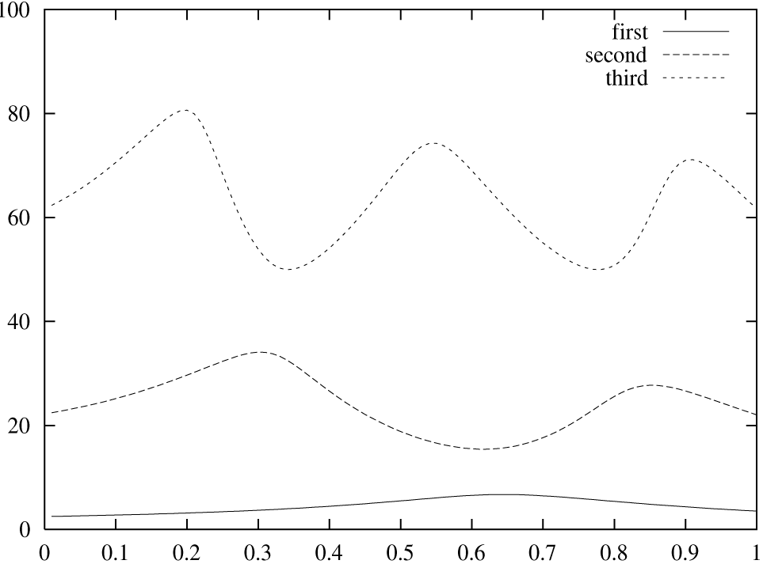

**Figure 1 -**  This is the caption for the figure.

${\left(x+a\right)}^{n}=\sum_{k=0}^{n}{\left({n \atop k}\right)x^{k}a^{n-k}}$. (1)

Equations should be referred to in abbreviated form, e.g., “Eq. (1)”. In multiple-line equations, the number should be given on the last line. The equation numbers should be consecutive.

# Figures

Figures are to be inserted in the text nearest their first reference. Please send one set of originals with copies in high resolution JPEG or TIF (minimum resolution 300 dpi). The image files must be collected in a folder and named according to the progressive numbering present in the text. The maximum size of the printed image is a grid of 18 cm x 18 cm. If you have a lower resolution image, please check the actual readability of the image by carrying out a print test since it is not enough to increase the number of dpi to improve its quality. Always indicate the figure's number and title, as well as the source (for figures taken from other publications).

All the figures will be printed in black and white on the printed Journal, but in the digital format in Open Access they will be visible in color. Therefore, avoid inserting references to the color in the captions and in the text and make sure that the choice of colors, if not accompanied by other distinctive elements (for example lines with different types of strokes) makes the figure legible in its transformation into gradations of Grey. The references to the figures in the text are indicated with (Fig. 1) / (Figs. 2-5), but are in full if inserted in the sentence in a discursive way: 'As seen in Figure 5 ...'. The graphs must be intended as figures and therefore they will have numbering and captions homogeneous with those of the figures. If photographs are to be used, only black and white ones are acceptable.

Figures are to be sequentially numbered in Arabic numerals. The caption must be placed below the figure. Typeset in 9 pt Optima with line spacing of 10 pt.

Previously published material must be accompanied by written permission from the author and publisher.

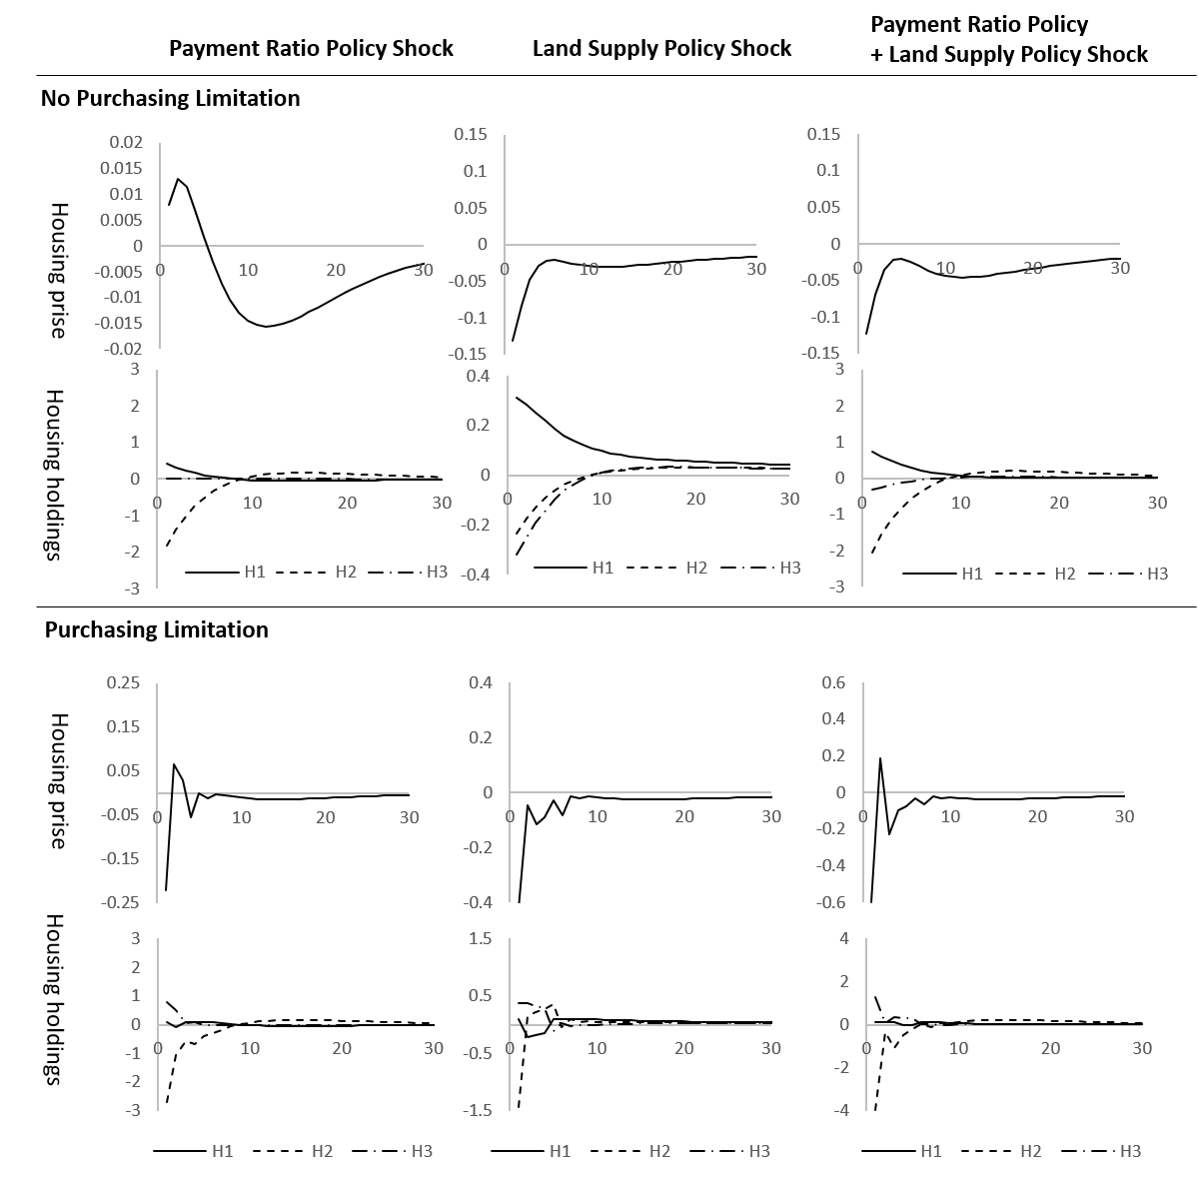

**Figure 1 -**  This is the caption for the figure. If the caption is less than one line then it is centered. Long captions are justified manually

If the figure is not readable in a single column and therefore a larger size is needed (full page width), insert page break “continuous" before and after the figure .

# Tables

Tables should be inserted in the text as close to the point of reference as possible.

**Table 1 -**  This is the caption for the table. If the caption is less than one line then it is centered.

|  |  |  |
| --- | --- | --- |
| **Schedule** | **Capacity** | **Level** |
| Business plan | Financial planning | Planning |
| Production planning | Resource requirement plan (RRP) |  |
| Final assembly schedule | Capacity control |  |
| Master production schedule | Rough cut capacity plan (RCCP) |  |
| Material requirement plan | Capacity requirement plan (CRP) |  |
| Stock picking schedule | Inventory control |  |
| Order priorities | Factory order control | Execution |
| Scheduling | Machine (work-centre) control |  |
| Operation sequencing | Tool controla |  |
| a If you must attach a note for further explaining some data in the table, please use 7 pts font size here | | |

Tables should be numbered sequentially in the text in Arabic numerals. . Typeset tables and captions in 9,5 pt Optima with single inter line.

If tables need to extend over to a second page, the continuation of the table should be preceded by a caption, e.g., “Table 1 (*Continued*).”.

# Running Heads

Please provide a shortened running head (not more than eight words) for the title of your paper. This will appear on the top right-hand side of your paper.

# Quotations

They must be inserted in quotation marks («exact quotation»), and if they are more than 5 lines long, you must go back and skip a line both at the beginning and at the end of the quotation. For these, use the italic font 9 pt Optima. If you want to skip a part of a quotation, indicate it with three dots in square brackets [...]. The quotations must be exact and must always be followed by the indication of the source (possibly including the page number).

# Footnotes

Footnotes should be numbered sequentially[1].

# Acknowledgments

This section should come before the References and Appendices. Funding information may also be included here.

1. Heading of Appendix

Appendices should be used only when absolutely necessary. They should come before the References. If there is more than one appendix, number them alphabetically. Number displayed equations occurring in the Appendix in this way, e.g., (A.1), (A.2), etc.

. (A.1)

* 1. This is the subappendix

They should come before the References. If there is more than one appendix, number them alphabetically. Number displayed equations occurring in the Appendix in this way, e.g., (A.1), (A.2), etc.

1. Another Appendix

Appendices should be used only when sophisticated technical details are crucial to be included in the paper. If there is more than one appendix, number them alphabetically. They should come before the References.

. (B.1)

# References

References are to be listed in alphabetical order using the last name of the first-named author, in the chronological order of publication of the works (for references by the same author published in the same year, use the indications a, b, c). They can be cited in text as, e.g. “According to Prigogine (1997) or “… (Partidario and Ars, 2005; Penna, 2008).” When there are more than three authors, the last name of the first author is written followed by et al. (in italics) (Moriani *et al*., 2008). Please list using the style shown in the examples. Full journal titles should be used. Typeset references in 9,50 pt Optima.

* **Firstname Lastname,** affiliation

e-mail: mail@mail.com

**\*\* Firstname Lastname,** affiliation

e-mail: mail@mail.com

**\*\*\* Firstname Lastname,** affiliation

e-mail: mail@mail.com

**Authors contributed**

The contribution the authors have made to the work should be included here

Bibliography

Prigogine I., *La fine delle certezze*, Bollati Boringhieri, Torino, 1997.

Monriani G., Ostoich M., Del Sole E. (eds.), *Metodologie di valutazione ambientale*, Franco Angeli, Milano, 2008.

Lind R.C. (ed.), *Discounting for Time and Risk in Energy Policy*, Johns Hopkins University Press, Baltimore, 1982.

Penna A., “Criteri ed indirizzi per la predisposizione del monitoraggio nella VAS”, in Colombo L., Losco S., Pacella C. (eds.), *La valutazione ambientale nei piani e nei progetti*, Edizioni Le Penseur, Potenza, 2008, pp. 255-266.

Egre D., Senecal P., *Social impact assessment of large dams throughout the world: lesson leant over two decades*, Impact Assessment & Project Appraisal, Vol. 21, No. 3, 2003, pp. 215-224.

Signorello G., *La valutazione economica del paesaggio*, Atti del XXXVI Incontro di Studio CeSET, Catania, 10-11 novembre 2006.

European Commission, La gestione della Rete Natura 2000. Guida all’interpretazione dell’art. 6 della Direttiva “Habitat” 92/43/CEE, Ufficio delle pubblicazioni ufficiali delle Comunità Europee, Lussemburgo, 2000.

World Bank, *Involuntary Resettlement*, Operational Directive 4.30, Washington, 1999a.

World Bank, *Operational Policies*, Operational Directive 4.01 – Environmental Assessment, Washington, 1999b.

Nuclei Regionali di Valutazione e Verifica degli Investimenti Pubblici, Studi di fattibilità delle opere pubbliche. Guida per la certificazione da parte dei Nuclei regionali di Valutazione e Verifica degli investimenti pubblici (NUVV), 2001 (scaricabile dal sito internet: http://www.retenuvv.it/documenti/attivita/rete/GUIDA_SDF.pdf, consultato on line il 18 dicembre 2009).

International Energy Agency, *World Energy Outlook*, International Energy Agency (IEA), Paris, 2009 (downloadable from the website: http://www.worldenergyoutlook.org/docs/weo2009/WEO2009_es_english.pdf, consulted online on March 27, 2010.

# Internet references

Istituto Ricerche Economiche e Sociali del Piemonte (IRES Piemonte), www.ires.piemonte.it.

Istituto Nazionale di Statistica (ISTAT), www.istat.it.

Ministero dell’Ambiente, www.minambiente.it

H:\documents\layout\new template June 2014\figures\CC-BY logo original v1.wmf© 2020 by the authors. Submitted for possible open access publication under the terms and conditions of the Creative Commons Attribution (CC BY) license (http://creativecommons.org/licenses/by/4.0/).

1. Footnotes should be typeset in 9 pt Optima at the bottom of the page